Instructions for Ridge Hook Assembly and Use
Important!: Please read these instructions carefully. Note the safe operational requirements, warnings, and cautions. Use the product correctly and with care for the purpose for which it is intended. Failure to do so may cause damage or personal injury and will invalidate the condition. Please keep instructions safe for further use.

Safety instructions
- DANGER! Take care when using and moving ladders in the area of power cables – risk of potentially fatal electrical shock.
- WARNING! Ensure Health and Safety, local authority, general regulations are adhered to when using this equipment.
- Familiarise yourself with the application and limitations of the Ridge hook, as well as potential hazards.
- Maintain the equipment in good condition.
- Replace or repair damaged parts. Use genuine parts only. Unauthorised parts maybe dangerous an will compromise the safety.
- Ensure the ridge hook are securely placed over the apex of the roof before placing any weight on the ladder.
- WARNING! Never overreach when on a ladder.
- Keep unauthorised persons away from the working area.
- DO NOT use the ladder ridge hook for any purpose other than for which it is designed.
- DO NOT use the equipment if any parts are damaged or missing as this may cause failure and/or personal injury.
- DO NOT use the equipment when you are tired or under the influence of alcohol, drugs, or intoxicating medication.
- When not in use store in a safe, dry, childproof area.

Contents of Ridge Hook
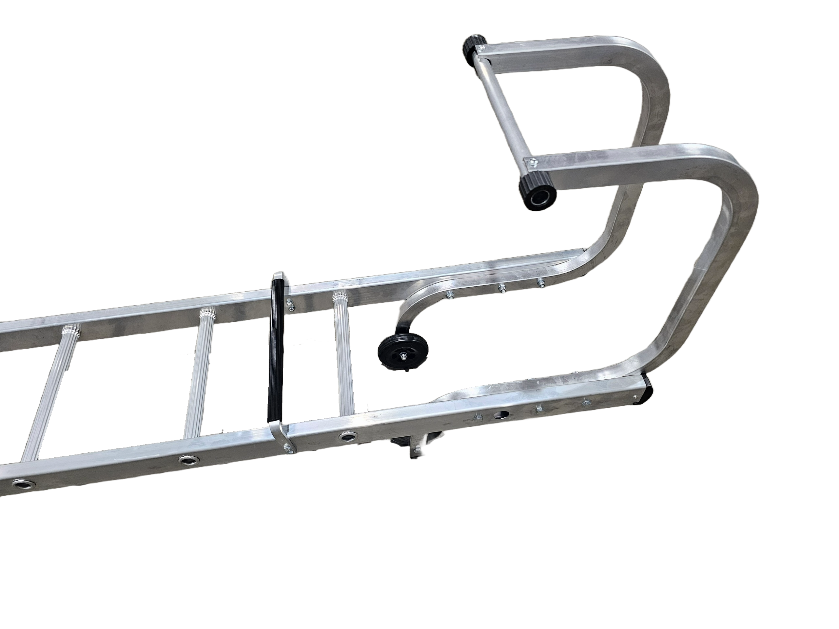
M8 X 65mm Hex-bolt | 8 | Spacers | 2
M8 Nut | 8 | Roof Hooks | 2
M8 Washer | 10 | Roof Hook Top rail | 1
Wheels | 2 | M5 x 40mm Hex-bolt | 2
M5 Washer | 2 | M5 Nut | 2

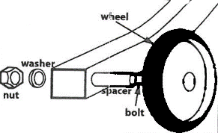
Assembly and Use
- Wheel Assembly
Insert the M8 x 65 Hex-bolt through the pre-drilled holes in the end of the box section of the Ridge Hook. Assemble wheel as pictured above, making sure that the wheels are on the inside of the box section. Insert the bolt through the wheel spacer, then slide wheel over the space and secure with washer and nut. Repeat with the other Ridge Hook. DO NOT overtighten.
- Attach the Roof Hooks (x2) to the ladder
Place the box section hook over the inside of the ladder stile. Insert three M8 x 65 Hex-bolt through the pre-drilled holes and secure with washer and nut. DO NOT overtighten.
- Repeat with the other Roof Hook. Position the other hook on the opposite side of the ladder.
- Attach Roof Hook Top Rail
Position the Roof Hook Top Rail over the ends of the roof hooks and secure with M5 washer nuts and bolts
- Make sure the ladder ridge hook is even and secure before use

Maintenance
Periodically check that all nuts are tight and secure but DO NOT overtighten
Check that the rubber end on the Top Rail is in good condition and are not worn.

